PROJECT DOCUMENTATION
Rising Water
AI-Powered Flood Prediction System using Machine Learning and Live Weather Data
Team Leader: Harshitha Badduri
Table of content:
S.no | Title | Page no
1 | Project overview | 1
2 | Objectives | 1
3 | Problem statement | 2
4 | Proposed solution | 2
5 | Core value proposition | 2
6 | Key features | 4
7 | Use case scenarios | 4
8 | System Architecture | 5-6
9 | Technology Stack | 6
10 | Machine Learning Model | 6-7
11 | Dataset Description | 7
12 | Data Preprocessing | 7
13 | Model Training | 8-9
14 | Prediction Workflow | 9
15 | API Integration | 9
16 | Frontend Design | 10
17 | System Requirements | 10
18 | Skills Required | 10-11
19 | Advantages | 11
20 | Limitations | 11
21 | Future Enhancements | 11
22 | Conclusion | 12
23 | Output | 12-14

- Project Overview
Rising Water
Floods are one of the most destructive natural disasters, causing severe damage to lives, agriculture, infrastructure, and the economy. Existing flood warning systems often depend on delayed reports or expensive monitoring infrastructure, making timely predictions difficult.
Rising Water is an AI-powered flood prediction web application designed to estimate flood risk using Machine Learning and live meteorological data. The application analyzes multiple environmental parameters including annual rainfall, monsoon intensity, river management indicators, climate variables, and live weather conditions to classify flood probability.
The application combines historical datasets with real-time weather information from Open-Meteo and displays predictions on an intuitive dashboard alongside an interactive rainfall radar powered by RainViewer.
The system is built using Python Flask, XGBoost, Bootstrap, Chart.js, and Leaflet.js, providing a responsive, scalable, and user-friendly platform for disaster preparedness.
- Objectives
The primary objectives are:
- Predict flood risk accurately using Machine Learning.
- Reduce disaster response time.
- Provide real-time weather synchronization.
- Display live precipitation radar.
- Assist authorities in early warning.
- Increase public awareness.
- Visualize prediction confidence.
- Create an easy-to-use web platform.

- Problem Statement
Flood prediction is traditionally dependent on manual observations, weather reports, and hydrological monitoring systems. These methods often suffer from delayed data collection and limited accessibility.
There is a need for an intelligent, automated system capable of analyzing multiple environmental factors and predicting flood risk instantly using Artificial Intelligence.
- Proposed Solution
The proposed solution is an AI-based web application that integrates:
- Machine Learning Prediction
- Real-Time Weather APIs
- Interactive Radar Maps
- Data Visualization
- Automated Risk Classification
The user can either:
- Detect their location automatically
- Enter location manually
The application retrieves weather data, processes user inputs, predicts flood probability using the trained XGBoost model, and visualizes the results through charts and maps.
- Core Value Proposition
• AI-powered flood prediction in seconds.
- Real-time weather synchronization without API keys.
- Live radar visualization.
- Accurate XGBoost classification.
- interactive dashboard.
- Easy accessibility through any web browser.
- Supports disaster preparedness and planning.
- Key Features
Feature | Description
Auto Location detection | Detects user location using browser GPS
Live Weather | Fetches temperature, humidity, rainfall, cloud cover
Machine Learning Prediction | XGBoost predicts flood probability
Interactive Radar | Displays live precipitation map
Dynamic Dashboard | Shows probability, risk level, charts
Data Visualization | Bar, Pie, Doughnut, Line Charts
Responsive UI | Mobile-friendly Bootstrap interface
Weather API Integration | Open-Meteo API
Rain Radar | RainViewer API

- Use case scenarios
Scenario 1: Government Disaster Management
Officials monitor flood-prone districts during monsoon season. The application predicts high flood probability, allowing early evacuation.

Scenario 2: Farmers
Farmers monitor expected rainfall before planting crops.

Scenario 3: Emergency Response Teams
Disaster management teams identify regions with the highest flood probability and allocate rescue teams efficiently.

Scenario 4: Public Users
Residents living near rivers check flood risk before traveling.

- Technical Architecture
System Flow
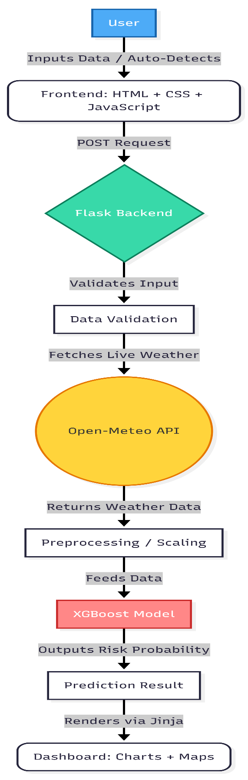
Component Architecture
Component | Role
User | Inputs weather parameters
Frontend | Displays dashboard
Flask Backend | API handling
ML Model | Predicts flood risk
Open-Meteo | Live weather
RainViewer | Radar Map
Chart.js | Graph visualization
Leaflet.js | Interactive maps

- Technology Stack
Layer | Technology
Backend | Flask
Frontend | HTML5, CSS3, Bootstrap 5
Programming | Python
Machine Learning | XGBoost
Data Processing | Pandas, NumPy
Model Training | Scikit-Learn
Charts | Chart.js
Maps | Leaflet.js
Weather API | Open-Meteo
Radar | RainViewer
Version Control | Git & GitHub

- Machine Learning Model
Algorithm Used
Extreme Gradient Boosting (XGBoost)
Reason for selection:
- High prediction accuracy
- Handles missing values efficiently
- Fast training
- Prevents overfitting
- Excellent performance on tabular datasets
Model Output
- Flood Risk
- Flood Probability (%)
- Confidence

- Dataset Description

The model is trained using a historical flood dataset consisting of environmental and meteorological parameters.
Example features include:
- Annual Rainfall
- Monsoon Intensity
- River Management
- Climate Change
- Drainage Systems
- Population Score
- Wetland Loss
- Urbanization
- Coastal Vulnerability
- Deforestation
- Dam Quality
- Temperature
- Soil Moisture
- Reservoir Capacity
- Topography
Total Features:
25 Environmental Variables
Target Variable:
Flood Probability (High / Low)

- Data Processing
Before model training:
- Missing Value Handling
- Feature Selection
- Label Encoding
- Standard Scaling
- Train-Test Split
- Data Normalization
- Model Training

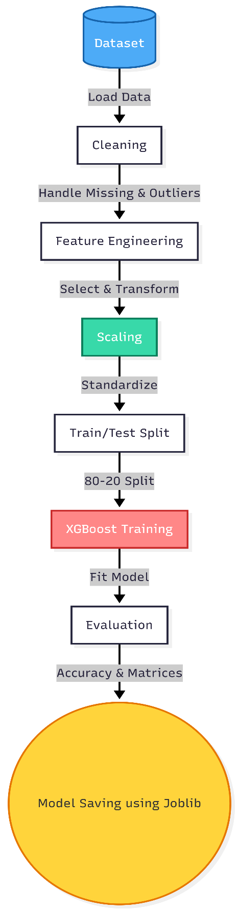
Evaluation Metrics:
- Accuracy
- Precision
- Recall
- F1 Score
- Confusion Matrix
- ROC-AUC

- Prediction Workflow
- User opens application.
- Location is detected.
- Weather API fetches live data.
- User enters remaining parameters.
- Data is preprocessed.
- XGBoost predicts flood probability.
- Dashboard displays risk level.
- Charts and radar map are updated.

- API Integration
Open-Meteo API
Used for:
- Temperature
- Humidity
- Cloud Cover
- Weather Conditions

RainViewer API
Used for:
- Live Rain Radar
- Storm Movement
- Precipitation Overlay

Nominatim API
Used for:
- Reverse Geocoding
- City Detection
- Coordinates

- Frontend Design
Ui Features
- Glassmorphism
- Bootstrap 5
- Responsive Layout
- Animated Cards
- Progress Bars
- Circular Gauge
- Interactive Charts
- Live Weather Widgets
- Dark Theme
- Mobile Responsive

- System Requirements
Hardware

Components | Requirement
Processor | Intel i3 or above
Ram | 4gb minimum
Storage | 2gb free
Internet | Required

Software

Components | Requirement
Python | 3.10+
Flask | Latest
Browser | Chrome/Edge
Vs Code | Recommended
Git | Latest Version

- Skills Required
• Python
• Flask
• Machine Learning
• XGBoost
• Data Preprocessing
• HTML
• CSS
• Bootstrap
• JavaScript
• REST APIs
• Git & GitHub
• Chart.js
• Leaflet.js

- Advantages
• Fast predictions
• Real-time weather updates
• Interactive interface
• High accuracy
• Lightweight deployment
• No paid APIs required
• Easy to scale
• Disaster preparedness support

- Limitations
• Depends on internet connectivity.
• Prediction quality depends on input accuracy.
• Limited by available historical data.
• Cannot replace official government warning systems.

- Future Enhancements
- Deep Learning (LSTM) forecasting
- Satellite imagery integration
- IoT water level sensors
- SMS and Email alerts
- Mobile application
- Multi-language support
- Cloud deployment (AWS/Azure/GCP)
- AI chatbot for disaster assistance
- Historical trend analysis

- Conclusion
Rising Water demonstrates the practical application of Artificial Intelligence and Machine Learning in disaster management by combining historical environmental data with real-time meteorological information. Through the XGBoost prediction model, live weather APIs, and interactive visualization tools, the system provides timely and reliable flood risk assessments. Its modular Flask architecture, intuitive dashboard, and scalable design make it a valuable solution for government agencies, disaster response teams, researchers, and the general public, contributing to improved preparedness and more informed decision-making during flood events.

- Output

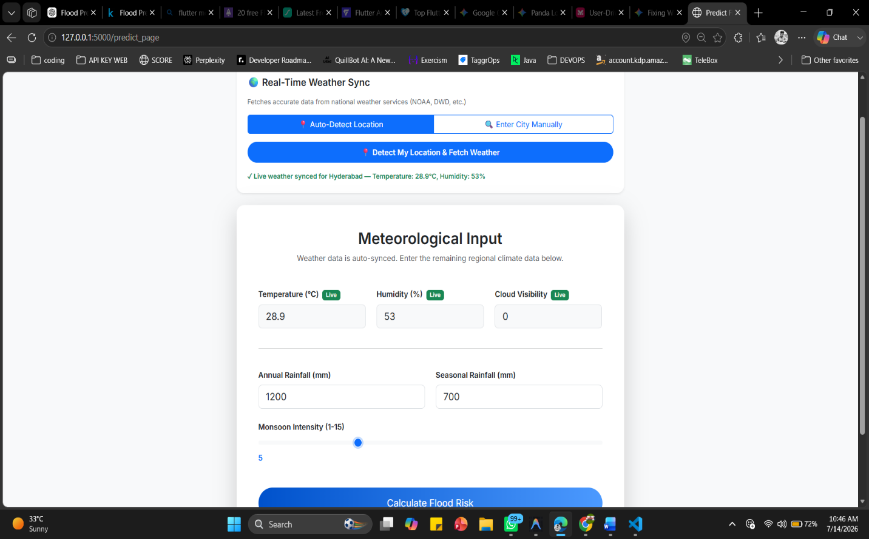
Input Fields

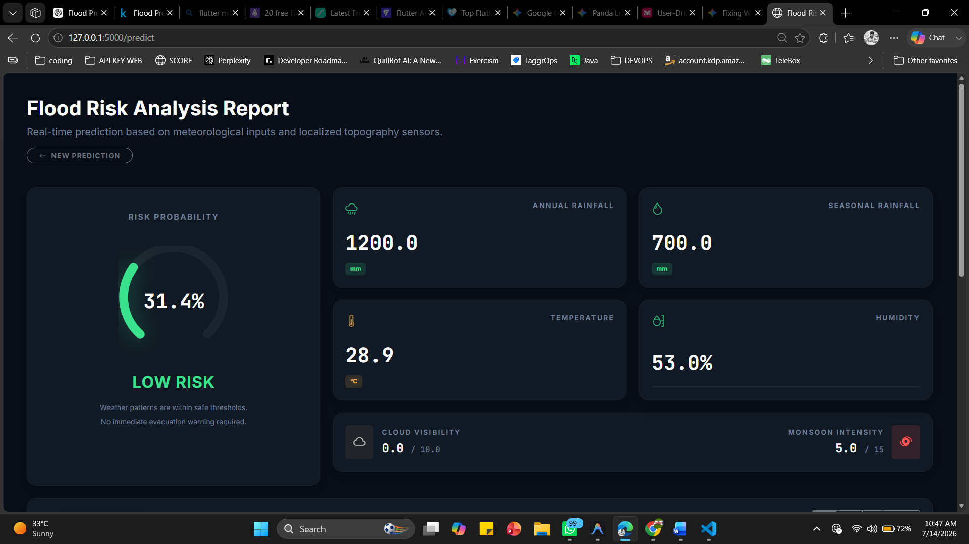
Analysis Report

Rainfall analysis with Live Precipitation Radar
